41 CLUB – ZAMBIA
2021 ANNUAL GENERAL MEETING
HOSTED BY LUSAKA NO.1 AT CIELA RESORT AND SPA, LUSAKA, ZAMBIA, 10 - 12TH SEPTEMBER 2021

REGISTRATION FORM

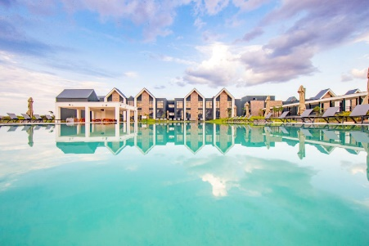
REGISTRATION
Member’s name: …………………………………….  41 Club name: …………………………………………  Office held: ……………………………………………. | Address: …………………………………………………  ……………………………………………………………….  ……………………………………………………………….  Postal Code: ………………………...................  Mobile phone: ……………………………….......  Email: ………………………………………………….
Registration packages (please tick one)
Full package
- Single: K2500.00 (US$119) [ ]
- With spouse: K3200.00 (US$152) [ ]
Saturday package
- Single: K1200.00 (US$57) [ ]
- With spouse: K1900.00 (US$90) [ ]
For details of packages see AGM flier
Conditions: All registration payments to be made before 25th August 2021. Any registration payment made after this date will attract a surcharge of K150.00 (US$7).
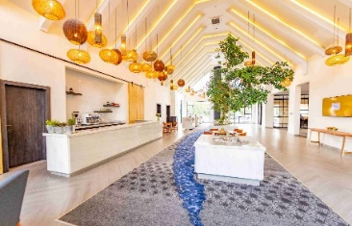 |  |  | Accommodation (B&B)  K2,646 (US$126)/night |  | Will play golf on 10th Sept 21 (Tee off: 15.00)
 |  |  | 1 Night | 2 Nights | Yes | No
 |  | Tick to select →
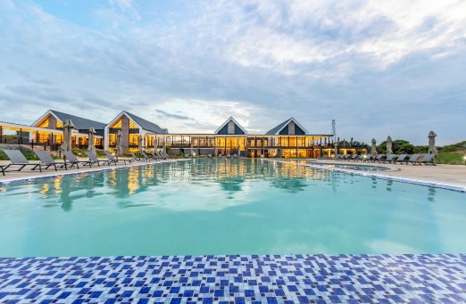

Payment to be made to:

Lusaka 41 Club
Indo Zambia Bank Plc
Account no: 0041040000099
Branch name: Kamwala
If making a direct transfer or deposit, please remember to include your name as narration and email copy of deposit slip and registration form to:
murrayandersonzm@gmail.com
 |  |  | 